SAMPLE PROPOSAL
State and Local Governments

THIS IS A SHORT, SIMPLIFIED SAMPLE OF AN INDIRECT
COST PROPOSAL. IF YOU WOULD USE THIS TYPE OF FORMAT,
THE INTERIOR BUSINESS CENTER COULD EXPEDITE THE
NEGOTIATION OF YOUR FIXED-WITH-CARRYFORWARD
INDIRECT COST RATE.

Information and examples used in this proposal
are all fictitious and
represent no particular state or local government organization.

U.S. Department of the Interior
Office of the Secretary
Indirect Cost Services
Financial Management Directorate
Interior Business Center

650 Capitol Mall, Suite 4-300
Sacramento, California 95814-4745
Telephone # (916) 930-3803
Fax # (916) 930-3804

E-mail Address: ICS@IBC.DOI.GOV
Website: https://ibc.doi.gov/ICS/icrna

Filing instructions: Proposals and audited financial statements are recommended to be submitted electronically to ICS@IBC.DOI.GOV as attachments preferably in 3 files: 1) Part 1 Sample Proposal, 2) Part 2 Exhibits (in Excel format, and 3) Audited Financial Statements.

Do NOT mail hard copy proposals.

The point(s) of contact listed in the proposal will receive an email from our office within five business days confirming the receipt of the proposal package. Please follow up to ensure that we have successfully received the package if you do not have receipt confirmation within five business days.
[State or Local Government Organization]
Indirect Cost Rate Proposal

TABLE OF CONTENTS

Page

CHECKLIST 3

INTRODUCTION 4

CERTIFICATE OF INDIRECT COSTS 5

ACCOUNTANT'S REPORT 6

ACCOUNTING SYSTEM DESCRIPTION 7

ORGANIZATION CHART 8

INDIRECT COST PERSONNEL JUSTIFICATIONS 9

SCHEDULE A, ELEMENTS OF COST 10

SCHEDULE B, SCHEDULE OF EXPENDITURE OF FEDERAL AWARDS 11

SCHEDULE C, CARRYFORWARD AND INDIRECT COST RATE COMPUTATION WITH FEDERAL PERCENTAGE 12

SCHEDULE D, SUMMARY SCHEDULE 13

SCHEDULE E, INDIRECT COST DETAIL SCHEDULE 14

SCHEDULE F, SCHEDULE OF INDIRECT SALARIES 15

SCHEDULE G, 3% LIMITATION ON SPORT FISH & WILDLIFE RESTORATION FUNDS 16

FINAL APPORTIONMENT OF PITTMAN-ROBERTSON 18

FINAL APPORTIONMENT OF DINGELL-JOHNSON 19

STATEWIDE COST ALLOCATION PLAN (SWCAP) 20

Indirect Cost Proposal (ICP) Checklist (State/Local Government)
£

1.

Contact person information

(preferably the person who prepared the proposal):

o

Entity Name and mailing address

___________________________________________

o

Employer Identification Number (EIN)

___________________________________________

o

Point
-
of
-
Contact Name and position title

___________________________________________

o

Email address (very important)

___________
________________________________

o

Phone & fax numbers

___________________________________________

o

Entity’s Internet website a
ddress, if any

___________________________________________

£

2. Signed
Certificate of Indirect C
osts
.

Page #______
_

£

3. Description of
accounting system
.

Page #_______

£

4. Applicable
audited financial statement
s

that meet the requirements of the Single Audit Act of 1984,

Public Law 98
-
502,

as amended. If Entity is under the
A
-
133 threshold ($750,000) and

does not have

an audit, then an
Accountant’s Report

and a copy of the general ledger is required
.

Page #_______

£

5.
Or
ganization
C
ha
rt
.

Page #_______

£

6.
Indirect Cost Personnel
Justifications
.

Page #_______

£

7. Entity’s written policy for allocating and identifying direct and indirect costs
(Schedule A,

El
ements of Cost)
.

Page #_______

£

8. Schedule of all
ex
penditures

by program title and grouped by funding agency with majority
F
ederal

funding list
ed

on top
(Schedule B, Schedule of Expenditure of Federal Awards)
.

Page #_______

£

9.
Schedule C, Carryforward and Indirect Cost Rate
Computation

(required if fixed with

Carryforward
indirect cost rate is requested for the third year and beyond).

Page #_______

£

1
0.
Federal percentage

–

the approximate percentage of the direct base funded by Federal sources for

each
year
that a rate is proposed.

Page #_______

£

11. A
schedule

that summarize
s

total costs by line item expenditure

(Schedule D, Summary

Schedule)

which should include but not be limited to:

Page #_______

o

Total expenditures (reconcil
able to the audit if using actual numbers)

o

Exclusions/Unallowable Costs with footnote explanation

o

Direct costs and indirect costs

£

12.
Schedule E,
Indirect Cost Detail Schedul
e
.

Page #_______

£

13. A breakdown of
indirect salaries

by position title, amount, indirect percentage, and grouped

by each
department
(Schedule F, Schedule of Indirect Salaries)
.

Page #_______

£

14.
Schedule G, 3% Limitation on Sport Fish & Wildlife Restoration Funds,
if applicable.

Page #_______

£

15.
Final Apportionment of Federal Aid Funds

letter and schedule(s) provided by U.S. Fish

and

Wildlife Service,

if applicable.
(See website:
http://wsfrprograms.fws.gov
.)

Page #_______

Final Apportionment of Pittman
-
Robertson (PR)

and
Final Apportionment of Dingell
-
Johnson (DJ)

£

16. An HHS Approved Statewide/Central Serv
ice Cost Allocation Plan (SWCAP/CSCAP) allocation

schedule for

the year being finalized. (See website
http://rates.psc.gov/fms/dca/dca_swcap.html
)

Page #_______

[State or Local Government Organization]
EIN: 11-1111111
Website: http://www.state.gov
Indirect Cost Rate Proposal

INTRODUCTION

The [State or Local Government Organization] has received an indirect cost rate from the Department of the Interior since fiscal year (FY) 1990. This proposal is based upon estimated budgets for all programs to be administered by the [Organization] during the period July 1, 20XX, through June 30, 20XX. All Federal, State, and district programs have been included in the proposal.

During the proposal fiscal year, no significant changes are anticipated, such as (a) to the accounting system, or (b) to the definition or to the accounting treatment of any expense category (e.g. a change in building/equipment costing methodology, capitalization level, or a change in charging an expense from direct to indirect or visa versa).

The individuals to contact in regard to this proposal are:

Ms. Julia Smith, Finance Manager
[State or Local Government Organization]
123 Middle Street
Upper, Washington 97865-1111
Tel (888) 555-1234
Email: jsmith@state.gov
Fax (888) 555-1240

Ms. Jane Down, Assistant Budget Officer
[State or Local Government Organization]
123 Middle Street
Upper, Washington 97865-1111
Tel (888) 555-2345
Email: jdown@state.gov
Fax (888) 555-1240

[State or Local Government Organization]
Indirect Cost Rate Proposal

Certificate of Indirect Costs

For State & Local Governments and Indian Tribes

This is to certify that I have reviewed the indirect cost rate proposal submitted herewith and to the best of my knowledge and belief:

- All costs included in this proposal [identify date] to establish billing or final indirect cost rates for [identify period(s) covered by the rate(s)] are allowable in accordance with the requirements of the Federal award(s) to which they apply and the provisions of 2 CFR Part 200 Subpart E-Cost Principles. Unallowable costs have been adjusted for in allocating costs as indicated in the indirect cost proposal.

- All costs included in this proposal are properly allocable to Federal awards on the basis of a beneficial or causal relationship between the expenses incurred and the agreements to which they are allocated in accordance with applicable requirements. Further, the same costs that have been treated as indirect costs have not been claimed as direct costs. Similar types of costs have been accounted for consistently and the Federal government will be notified of any accounting changes that would affect the predetermined rate.

I declare that the foregoing is true and correct.

Governmental Unit:
Signature:
Name of Official (printed):
Title:
Email:
Date of Execution:

This certification:
- Is a requirement per 2 CFR Part 200 Subpart E §200.415 and Appendix VII Section D.3.;
- Must be submitted as part of the annual indirect cost rate proposal; and
- Must be signed on behalf of the non-Federal entity by an individual at a level no lower than vice president or chief financial officer of the organization.

NOTE: THIS REPORT OR ONE SIMILAR, ACCOMPANIED BY A COPY OF THE GENERAL LEDGER, IS REQUIRED ONLY FOR STATE OR LOCAL GOVERNMENT ORGANIZATIONS THAT ARE IN THEIR THIRD YEAR OF INDIRECT COST PROPOSAL NEGOTIATIONS WHEN NO CURRENT AUDITED FINANCIAL STATEMENT IS AVAILABLE.

ACCOUNTANT’S REPORT

We have examined management’s assurances that [State or Local Government Organization] meets the standards for grantee financial management systems and related internal controls required by Title 25, Chapter 1, of the Code of Federal Regulations, Part 276.7, and reviewed the bookkeeping and accounting systems of the [Organization] and the related internal controls do determine if the existing system and controls are in compliance with the standards set forth in Title 25, Chapter 1, of the Code of Federal Regulations, Part 276.7., by providing for the following:

1. Accurate, current, and complete disclosure of the financial results of each contract and/or grant program in accordance with Federal reporting requirements.

2. Records that identify adequately the source and application of funds for each contract and/or grant program.

3. Effective control over, and accountability for, all contract and/or grant or subgrant funds and real and personal property acquired with grant or subgrant funds.

4. Comparison of actual costs with budgeted amounts for each contract and/or grant or subgrant.

5. Procedures to minimize the time elapsing between the transfer of funds from the U.S. Treasury and the disbursement by the grantee.

6. Procedures for determining the allowability and allocability of costs with the applicable cost principles.

7. Accounting records that are supported by source documentation.

8. A systematic method to assure timely and appropriate resolution of audit findings and recommendations.

We understand that procedures in conformity with the above criteria are considered by most granting agencies to be adequate for their purpose, and that procedures not in conformity with those criteria indicate some inadequacy for such purposes. In our opinion based on this understanding and our review and testing of the management systems for record keeping, personnel, procurement, financial management and property management, the [Organization] financial management systems are adequate to meet the criteria established in Title 25, Chapter 1, of the Code of Federal Regulations, Part 276.7.

This report is intended for the information of the State or Local Government and federal and state granting agencies; it should not be used for any other purpose.

CPA's Signature and Date
[State or Local Government Organization]
Indirect Cost Rate Proposal

ACCOUNTING SYSTEM DESCRIPTION

The [State or Local Government Organization] has an automated, double-entry, accrual system of accounting. Separate journals and ledgers (organization codes and project numbers) are maintained for each individual program in the direct cost base. A separate journal and a general ledger (organization codes and project numbers) are also maintained for the indirect cost pool.

[State or Local Government Organization]

Organization Chart as June 30, 20XX

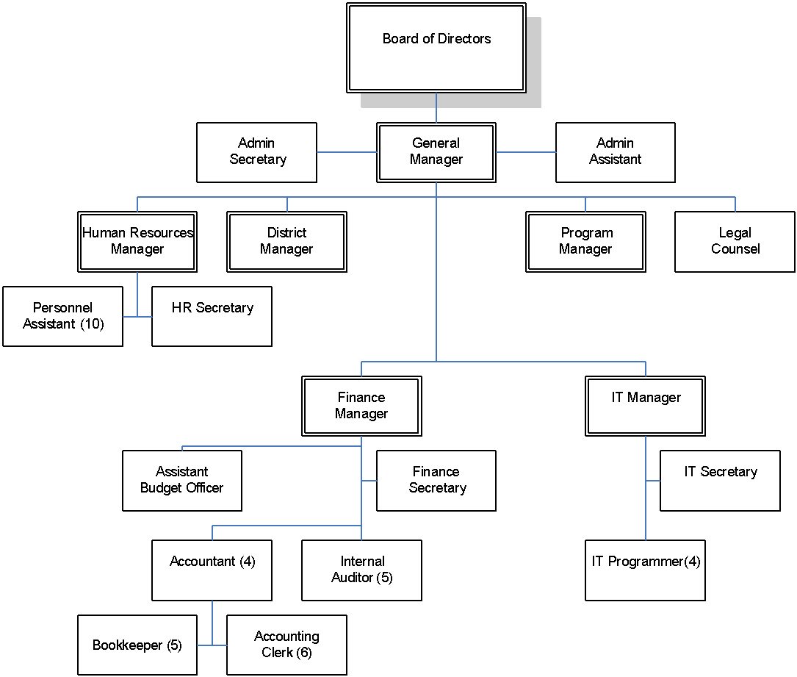

[State or Local Government Organization]

Indirect Cost Rate Proposal

INDIRECT COST PERSONNEL JUSTIFICATIONS

The following account of each position should provide the necessary justification to fund administrative costs through the indirect cost pool for fiscal year 20XX.

GENERAL MANAGER: The General Manager has administrative responsibility for all staff and activities of the [Organization]. Under the direction of the Board of Directors, the General Manager plans, administrates through subordinate supervision, reviews and evaluates all Organizational functions and activities; ensures that such activities are carried out within statutory, budgetary and policy guidelines. The General Manager is also responsible for representing the [Organization] in negotiations of grants/contracts; coordinating the direction of the [Organization]; and representing the [Organization] in meetings with governmental and business [Organizations], community groups, developers, customers and the public. Therefore, only 40 percent of the General Manager’s time is charged to indirect administration, with the remaining 60 percent charged direct to contracts and program activities.

FINANCE MANAGER: This position handles the business activities of the [Organization]. The Finance Manager develops and administers the annual budget for the [Organization]; reviews and authorizes expenditures; plans and recommends revenue strategies, and implements plans after approval by General Manager and the Board. This position will be responsible for the business department and also be involved in program business activities, with 80 percent of the time chargeable to indirect administrative costs.

ASSISTANT BUDGET OFFICER (ABO): The ABO serves as interim Finance Manager during her absence. The ABO plans, organizes, directs and coordinates the administrative support functions of the [Organization]. Specifically, the ABO provides general management and administration of the [Organization]’s billing and collection system, personnel, accounting, customer service, records maintenance and related office support services. In addition, the ABO assists in budget preparation and monitors and controls administrative costs.

BOOKKEEPERS: These positions are responsible for maintaining the books of entry for all programs and ensuring that the financial system is kept current. Specifically, the Bookkeepers perform accounting work of a technical nature and assist in the financial operation of the [Organization]. Major duties include maintenance of accounts payable, receivable, cash disbursements and the general ledger. In addition, the bookkeepers reconcile bank statements and all monthly financial reports, as necessary, for the General Manager.

ACCOUNTING CLERKS: This position is part of the centralized accounting department of the [Organization]. The Accounting Clerk is responsible for distributing payroll for all programs and ensuring that the proper reports and records are kept current. This position also assists with the accounts payable.

[State or Local Government Organization]
Indirect Cost Rate Proposal

Elements of Cost Schedule A

Elements of Cost |  | Methodology of Allocation
Contractual services |  | Actual usage
Depreciation / use allowance |  | Direct and Indirect cost
Emergency assistance payments |  | Direct cost
Equipment rental and maintenance |  | Rental and maintenance on equipment used in central office finance office
Equipment / capital |  | Purchasing of office furniture for use in performing administrative services
Equipment / minor |  | Actual usage
Insurance |  | Actual usage
Occupancy |  | Central office repairs and utilities on basis of square footage used for administrative services
Office supplies |  | Office and janitorial supplies for administrative and program services
Other expenses |  | Based on administrative services actual use
Postage |  | Actual usage
Printing |  | Actual usage
Professional fees |  | Accounting and audit services, payroll processing services, charged on work performed for administrative services
Program materials |  | Direct cost
Program supplies |  | Charged to project as costs are incurred; direct cost
Renovations and improvements |  | Direct cost
Telephone |  | Basic services allocated on number of instruments, toll calls charged on basis of logs of such calls for administrative services
Travel |  | Actual usage
The methodologies used in this example are not recommended methodologies. They are used for demonstration purposes only. Allocation of costs should be accomplished on a cost benefit basis. This cost benefit can be different from one organization to the next.

[State or Local Government Organization]
Indirect Cost Rate Proposal

Schedule of Expenditure of Federal Awards as of 6/30/20XX Schedule B

Program Title Expenditures

Department of the Interior:
Fish & Wildlife $17,345,528

Environmental Protection Agency:
Program A.1 4,734,528
Program A.2 2,239,954

Department of Agriculture:
Program B.1 1,482,211
Program B.2 925,899

Total Federal Funding $26,728,120

 | Schedule C
[State or Local Government Organization]
Carryforward and Indirect Cost Rate Computation with Federal Percentage
Fiscal Year Ending June 30, 20XX
TITLE/DESCRIPTION | YEAR-ENDING AMOUNTS
FY 20XX Direct Cost Base (based on actual costs incurred) | $41,765,945 | *
FY 20XX Indirect Cost Rate (per FY 20XX Negotiation Agreement) | 5.82%
FY 20XX Recoverable Indirect Costs | $2,430,778
FY 20XX Indirect Costs (based on actual costs incurred) | $2,600,280 | *
FY 20XX SWCAP | 18,240 | *
FY 20XX Under(Over)recovery Carryforward to FY 20XX (per Negotiation Agreement) | (354,125)
FY 20XX Indirect Cost Pool | 2,264,395
Less FY 20XX Recoverable Indirect Costs (from above) | (2,430,778)
FY 20XX Under(Over)recovery Carryforward to FY 20XX | (166,383)
FY 20XX Indirect Costs (proposed) | 2,600,280 | **
FY 20XX SWCAP | 18,240 | **
FY 20XX Indirect Cost Pool | $2,452,137
FY 20XX Direct Cost Base (proposed) | $41,765,945 | ** 1/
FY 20XX Indirect Cost Rate | 5.87%

* Please provide detail support for actual indirect and actual direct base costs reconcilable to financial statements that meet the requirements of the Single Audit Act of 1984, Public Law 98-502.

** Please provide detail support for proposed indirect and direct base costs when using budgeted numbers and indicate the percentage of Federal funding in the base. Separate Schedules C, D, E and F will be required.

1/ Federal funding percentage = 65%

[State or Local Government Organization]
Indirect Cost Rate Proposal

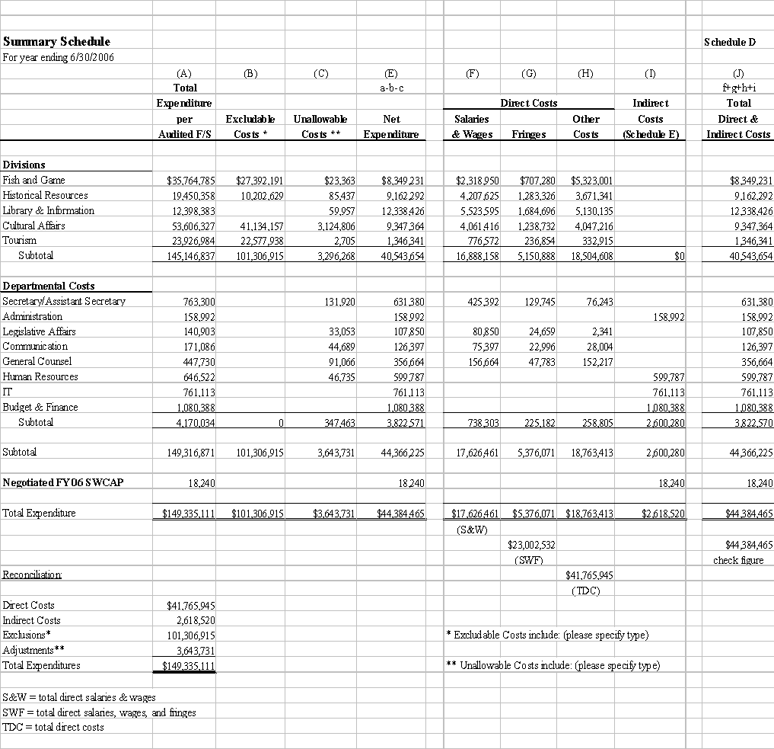
[State or Local Government Organization]
Indirect Cost Rate Proposal

Indirect Cost Detail Schedule* |  |  |  |  |  |  | Schedule E
For year ending 6/30/XX
 |  | Human |  | Budget &
Line Item Costs | Administration | Resources | IT | Finance |  | Total
Salaries & wages** | $95,000 | $250,000 | $210,000 | $550,000 |  | $1,105,000
Fringe benefits | 29,000 | 75,000 | 63,000 | 165,000 |  | 332,000
Advertising |  | 40,000 |  | 20,000 |  | 60,000
Communications | 8,000 | 16,000 | 25,000 | 20,000 |  | 69,000
Dues & subscription | 2,000 | 4,000 | 8,000 | 10,000 |  | 24,000
Freight & handling | 5,000 | 10,000 | 25,000 | 15,000 |  | 55,000
Insurance | 1,300 | 26,000 | 26,000 | 28,000 |  | 81,300
Printing | 4,000 | 8,000 | 10,000 | 20,000 |  | 42,000
Professional services |  | 99,000 | 150,000 | 113,000 |  | 362,000
Rental | 750 | 15,000 | 35,000 | 22,000 |  | 72,750
Repairs & maintenance | 1,000 | 2,000 | 100,000 | 27,500 |  | 130,500
Travel & Per Diem |  | 15,000 | 45,000 | 50,000 |  | 110,000
Janitorial | 400 | 1,200 | 1,200 | 2,000 |  | 4,800
Security services | 2,500 | 5,000 | 5,000 | 5,000 |  | 17,500
Utilities | 800 | 1,600 | 5,000 | 5,000 |  | 12,400
Supplies | 9,000 | 18,000 | 45,000 | 25,000 |  | 97,000
Miscellaneous expenses | 242 | 13,987 | 7,913 | 2,888 |  | 25,030
Total | $158,992 | $599,787 | $761,113 | $1,080,388 |  | $2,600,280

* Schedule of indirect costs (proposed and actual) is sufficiently detailed to determine the purpose and classification, including salaries and unallowable expenses (e.g. contributed salaries and services, interest expense, bad debts, advertising, depreciation on federally funded assets and lobbying costs) have been eliminated from the indirect cost pool.

** Please provide indirect salaries breakdown by position title, % included as indirect, amount, and grouped by each department. See Schedule F.

[State or Local Government Organization]
Indirect Cost Rate Proposal

Schedule of Indirect Salaries Schedule F

Title/Description |  |  | Annual Salaries |  | % Indirect |  | Indirect Salaries
Salaries:
 | Administration
 |  | General Manager | $124,385 |  | 40% |  | $49,754
 |  | Admin Assistant | 66,436 |  | 38% |  | 25,246
 |  | Admin Secretary | 47,619 |  | 42% |  | 20,000
 | Subtotal Administration |  |  |  |  |  | 95,000
 | Human Resources
 |  | HR Manager | 45,000 |  | 100% |  | 45,000
 |  | HR Secretary | 20,000 |  | 100% |  | 20,000
 |  | Personnel Assistant (10) | 185,000 |  | 100% |  | 185,000
 | Subtotal Human Resources |  |  |  |  |  | 250,000
 | Information Technology
 |  | IT Manager | 48,500 |  | 100% |  | 48,500
 |  | IT Secretary | 21,500 |  | 100% |  | 21,500
 |  | IT Programmers (4) | 140,000 |  | 100% |  | 140,000
 | Subtotal Info Tech |  |  |  |  |  | 210,000
 | Budget & Finance
 |  | Finance Manager | 61,250 |  | 80% |  | 49,000
 |  | Assistant Budget Officer | 43,000 |  | 100% |  | 43,000
 |  | Finance Secretary | 20,000 |  | 100% |  | 20,000
 |  | Accountants (4) | 120,000 |  | 100% |  | 120,000
 |  | Accounting Clerk (6) | 105,000 |  | 100% |  | 105,000
 |  | Bookkeeper (5) | 87,500 |  | 100% |  | 87,500
 |  | Internal Auditor (5) | 125,500 |  | 100% |  | 125,500
 | Subtotal Budget & Finance |  |  |  |  |  | 550,000
Total Indirect Salaries & Wages |  |  |  |  |  |  | $1,105,000

3% LIMITATION ON SPORT FISH & WILDLIFE RESTORATION FUNDS Schedule G
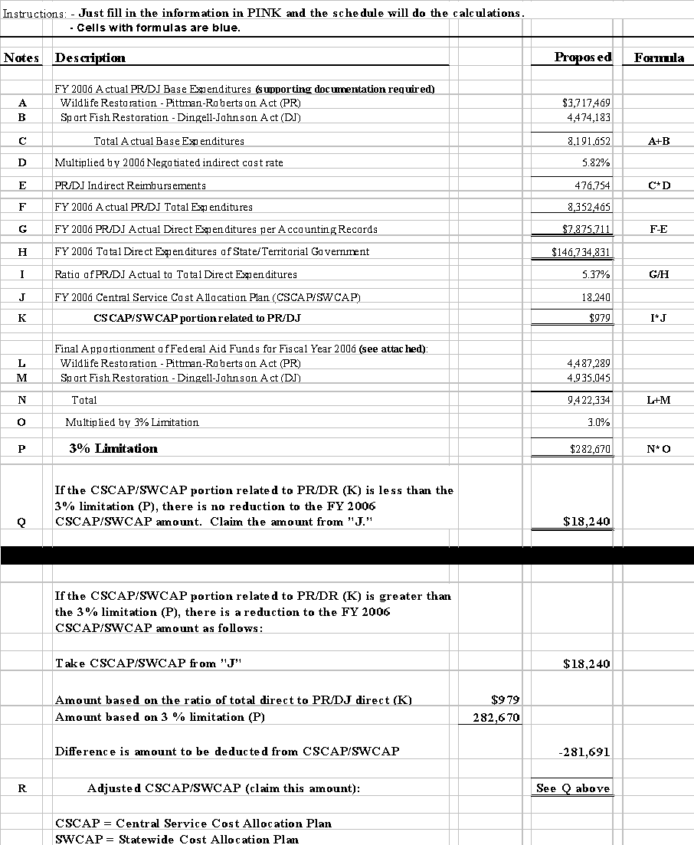
NARRATIVE / Schedule G-1
Notes |  | Remarks
A |  | Actual expenditures as they relate to the direct Pittman-Robertson (PR) Act expenditures that were included in the actual direct cost base used to negotiate the indirect cost rate(s); e.g., modified direct costs (excludes capital expenditures and other distorting items, such as passthrough funds, major subcontracts, etc.), direct salaries and wages, or another base which results in an equitable distribution, such as direct salaries and wages including fringe benefits.
B |  | Actual expenditures as they relate to the direct Dingell-Johnson (DJ) Act expenditures that were included in the actual direct cost base used to negotiate the indirect cost rate(s); e.g., modified direct costs (excludes capital expenditures and other distorting items, such as passthrough funds, major subcontracts, etc.), direct salaries and wages, or another base which results in an equitable distribution, such as direct salaries and wages including fringe benefits.
C |  | This is a calculated amount. It totals the expenditures for the two Acts to arrive at total actual base expenditures.
D |  | Indirect cost rate negotiated for actual cost year; e.g., if the actual expenditures above are FY 2006 expenditures, then the negotiated FY 2006 indirect cost rate is to be used.
E |  | This is a calculated amount. It determines the recoverable indirect costs using the direct cost base related to the PR/DJ direct expenditures and the negotiated indirect cost rate.
F |  | Total actual PR/DJ expenditures including everything expended and recorded against the Acts.
G |  | This is a calculated amount. It determines the actual direct expenditures for the PR/DJ and is calculated by reducing the total actual PR/DJ expenditures by the recoverable indirect costs.
H |  | Total actual direct expenditures for the state/territorial government or department and before any adjustments.
I |  | This is a calculated amount. It calculates the ratio of the PR/DJ expenditures to the total direct expenditures as a percentage. This percentage is used to calculate the portion of the Central Services Cost Allocation Plan (CSCAP) and/or Statewide Cost Allocation Plan (SWCAP) that is allocable to the PR/DJ expenditures.
J |  | Total CSCAP/SWCAP of actual cost year, in this example FY 2006.
K |  | This is a calculated amount. It determines the amount allocable to the PR/DJ from the CSCAP/SWCAP.
L |  | This is the final apportionment amount of the Federal Aid in Wildlife Restoration (PR) Funds for the actual cost year. It can be obtained from the Wildlife and Sport Fish Restoration Programs’ Division of Federal Assistance home page of the U.S. Fish & Wildlife Services at http://wsfrprograms.fws.gov.
M |  | This is the final apportionment amount of the Federal Aid in Sport Fish Restoration (DJ) Funds for the actual cost year. It can be obtained from the Wildlife and Sport Fish Restoration Programs’ Division of Federal Assistance home page of the U.S. Fish & Wildlife Services at http://wsfrprograms.fws.gov.
N |  | This is a calculated amount. It determines the total apportionment for PR/DJ funds for actual cost year.
O |  | Three percent limitation, see 50 CFR Part 1, Wildlife and Fisheries, chapter I, paragraph 80.15(d).
P |  | This is a calculated amount. It determines the 3 percent limitation on CSCAP.
Q |  | If the CSCAP/SWCAP portion related to PR/DR (K) is less than the 3% limitation (P), there is no reduction to the FY 2006 CSCAP/SWCAP amount. Claim the amount from "J."
R |  | This is a calculated amount. If the portion of CSCAP/SWCAP related to PR/DJ (K) is greater than the 3 percent limitation (P) then the difference between the amount based on the ratio of direct expenditures and the amount calculated using the apportionment and limitation is calculated. The outcome is deducted from the actual year CSCAP/SWCAP amount, resulting in the CSCAP/SWCAP that can be claimed (See "Q" above).

