Sample Cost Allocation Plan for State and Local Governments

Name of Organization (EIN: 02-9876543)
1234 Front Street
Anytown, State 95668-1111
Tel. (123) 456-7890, Fax (123) 456-7891

Contact Person(s):

Robert Smith, Executive Director Email: rsmith@Organization.org
Andrea Brown, Finance Officer Email: abrown@Organization.org
A. INTRODUCTION
“Name of Organization” is a state/local government located in Anytown, State. The Organization administers a variety of programs funded by Federal, State, and Local agencies. These programs include Community Service programs, Head Start programs, State Source Reduction Assistance Programs, Pollution Prevention Grants, and Environmental Policy and Innovation Grants. (This example assumes a June 30 year end. Organizations can have different year ends and should use their year end when preparing cost allocation plans.)
B. COST ALLOCATION METHODOLOGY
This proposal is for a Cost Allocation Plan (Plan) to cover the period beginning July 1, 200X and ending June 30, 200Y. This proposal is based on the Organization's actual costs reconcilable to the audited financial statements for its fiscal year ending June 30, 200Y. The status of our cost allocation plan is (please select one):

(a) This is our initial request for the approval of our cost allocation plan. None of the federal
agencies have ever officially approved of our cost allocation plan.
(b) We have received an official written approval of our cost allocation plan from Department of
SYZ Federal funding agency (other than Interior Business Center, U.S. Department of the
Interior). Attached you will find our 3 most recent approval letters.
(c) We have received an official written approval of our cost allocation plan from Interior Business
Center, U.S. Department of the Interior.

This proposal addresses all elements of cost incurred by the Organization and identifies shared costs that require allocation. The Organization treats all costs as direct costs except general administration and general expenses. Joint costs are prorated individually as direct costs to each category and to each award using a base most appropriate to the particular cost being prorated. Therefore, the direct allocation method has been used in allocating indirect costs.
Organization maintains adequate internal controls to insure that no cost is charged both directly and indirectly to Federal contracts or grants.
C. DIRECT COSTS
Direct costs are costs that can be identified specifically with a project and therefore are charged to that project. The accounting system records these costs as they are incurred within the series of accounts assigned for that purpose. Further distribution is not required.
D. INDIRECT COSTS
Indirect costs are costs incurred for common or joint objectives and therefore cannot be readily and specifically identified as a particular project or activity. Indirect costs are (please select one):

(a) direct charged to all programs and grants, or
(b) grouped into common pool(s) and then distributed to benefiting activities by a cost allocation process.
(c) none of the above. Indirect costs are _(fill in the blank)______________________________.

E. COST POOL AND BASE FOR DISTRIBUTION
The Organization has created an Administrative Services (Indirect) Pool consisting of salaries, fringe benefits, and other costs. The Administrative Services (Indirect) Pool is charged with all the indirect costs as defined above. The pool is distributed to the various program activities on the basis of {state the distribution bases, e.g. direct salaries, including vacation, holiday, and sick pay but excluding other fringe benefits expended on those activities; direct salaries and wages, excluding fringe benefits; direct salaries and wages, including fringe benefits; modified total direct costs, less capital expenditures and the portion of subawards in excess of $25,000.} Each category of non-salary expenditures has been analyzed based on the facts, and the Elements of Cost (Schedule A) explains the allocation between Direct and Administrative Services (Indirect) Costs.
F. SUPPORTING FINANCIAL STATEMENTS, SUMMARY SCHEDULE AND UNALLOWABLE COSTS
NOTE: Organization must include a complete copy of the audited financial statements with their proposal submission.
The Schedule of Total Expenditures (Schedule B) contained in this proposal agrees with the Organization’s audit report and/or Statement of Functional Expenses. Any differences must be explained.
Unallowable and Excludable Costs – The following costs have been excluded from the allocation process: {List specific costs, such as capital outlay over the threshold of $5,000, entertainment, fines and penalties, bad debts, and food costs, etc.}
G. DESCRIPTION OF ACCOUNTING SYSTEM
{SAMPLE – Adjust to fit your organization} The [state entity] uses a [modified accrual] system of accounting. Under the [modified accrual] basis of accounting, revenues are recognized when susceptible to accrual (i.e. when they become both measureable and available). “Measurable” means the amount of the transaction can be determined, and “available” means collectible within the current period or soon enough thereafter to be used to pay liabilities of the current period. A one-year availability period is used for revenue recognition for all federally-funded revenue. Expenditures are recorded when the related liability is incurred.
We have not made any significant changes [or We have made significant changes] during the proposal fiscal year (1) to our accounting system, or (2) to the definition or to the accounting treatment of any expense category (e.g. a change in building/equipment costing methodology, capitalization level, or a change in charging an expense from direct to indirect or visa versa). Note: Changes in the allocation methodology should be identified here as well as reported on the Element of Costs (Schedule A). See Section E above.
H. INDIRECT SALARIES
Listed below are the positions, functions, and annual salaries for the people who comprise the Administrative Services Pool. These positions are charged the applicable percentage to Administrative Services.
Position and % Indirect 1/ | Function | Salary
Executive Director (100%) | General Management | $48,754
Deputy Director (100%) | General Management | $30,664
Administrative Assistant to Executive Director (100%) | General Management | $21,566
Administrative Secretary / Personnel Officer (100%) | Clerical support to the Executive Director and Administrative Assistant responsible for personnel information | $17,087
Finance Officer (100%) | Accounting and related activities | $26,484
Bookkeeper (100%) | Accounting | $20,797
Bookkeeper (50%) | Accounting | $17,215
Bookkeeper / Payroll Clerk (50%) | Payroll accounting and general disbursements | $16,560
Custodian (25%) | Cleaning | $2,936
Receptionist (100%) | Switchboard / Clerical | $14,232
 | Total Administrative Services Pool Salaries: | $216,295
1/ If the indirect percentage for any employee is less than 100%, please include a description of the state entity’s timekeeping system to support compliance with the standards of 2 CFR 225 Appendix B Subsection 8.h.(4). Also, please provide a recently completed time sheet.
I. INDIRECT FRINGE BENEFITS
Fringe benefits associated with the positions within the Administrative Services (Indirect) Pool are as follows:
Payroll taxes:
 | FICA (actual paid) |  | $16,546
 | State Unemployment  (actual paid) |  | $1,145
 | Health and Life Insurance (actual paid) |  | $22,474
 | Retirement Plan  (actual paid) |  | $3,050
 | TOTAL |  | $43,215
The Organization’s fringe benefit policies should be included with initial proposal submission and only when updated thereafter.
J. SCHEDULE OF FINANCIAL ASSISTANCE
See Schedule C.
K. ORGANIZATION CHART
See Schedule D
L. COST ALLOCATION PLAN CERTIFICATION
See Attached

I certified that the above cost allocation plan is correct and accurate to the best of my knowledge.
Signature:
Print Name:
Title:
Email:
Date:
SCHEDULE A – Elements of Cost {adjust to fit your organization}
Elements of Cost |  | Methodology of Allocation
Contractual services |  | Actual usage
Depreciation / use allowance |  | Indirect cost
Emergency assistance payments |  | Direct cost
Equipment rental and maintenance |  | Rental and maintenance on equipment used in central office finance office
Equipment / capital |  | Purchasing of office furniture for use in performing administrative services
Equipment / minor |  | Actual usage
Program materials |  | Direct cost
Insurance |  | Actual usage
Occupancy |  | Central office repairs and utilities on basis of square footage used for administrative services
Office supplies |  | Office and janitorial supplies for administrative and program services
Other expenses |  | Based on administrative services actual use
Postage |  | Actual usage
Professional fees |  | Accounting and audit services, payroll processing services, charged on work performed for administrative services
Program supplies |  | Charged to project as costs are incurred; direct cost
Printing |  | Actual usage
Renovations and improvements |  | Direct cost
Telephone |  | Basic services allocated on number of instruments, toll calls charged on basis of logs of such calls for administrative services
Travel |  | Actual usage
The methodologies used in this example are not recommended methodologies. They are used for demonstration purposes only. Allocation of costs should be accomplished on a cost benefit basis. This cost benefit can be different from one Organization to the next. Any change in the allocation methodology (from the prior year) should be explained. Also, include explanatory information for individual cost elements as shown above.

Schedule B |  |  |  |  | DIRECT PROGRAMS and ACTIVITIES (6/30/xx)
A | B | C |  | D |  | E | F | G |  | H | I
ELEMENTS OF COSTS | FINANCIAL STATEMENT EXPENDITURES | ADJUSTMENTS/ UNALLOWABLE COSTS |  | ENVIRONMENTAL SERVICES |  | HEAD START & OTHERS | WEATHERI-ZATION | FUNDRAISING | (D)+(E)+(F)+(G) TOTAL DIRECT COSTS |  | INDIRECT COSTS
Salaries and wages | $1,327,638 | 0 |  | $140,831 |  | $950,615 | $18,305 | $1,592 | $1,111,343 |  | $216,295
Fringe benefits | $245,434 | 0 |  | $28,138 |  | $170,107 | $3,657 | $317 | $202,219 |  | $43,215
Subtotal labor & fringes | $1,573,072 | 0 |  | $168,969 |  | $1,120,722 | $21,962 | $1,909 | $1,313,562 |  | $259,510
Contractual services | $245,420 | 0 |  | $3,493 |  | $207,770 | $34,157 | $0 | $245,420 |  | $0
Depreciation/use allowance | $41,582 | 0 |  | $0 |  | $0 | $0 | $0 | $0 |  | $41,582
Emergency asst. payments | $72,859 | 0 |  | $52,809 |  | $0 | $20,050 | $0 | $72,859 |  | $0
Equipment rental and maintenance | $11,448 | 0 |  | $592 |  | $5,197 | $0 | $281 | $6,070 |  | $5,378
Equipment / capital | $58,215 | ($58,215) | 1/ | $0 |  | $0 | $0 | $0 | $0 |  | $0
Equipment / minor | $546 | 0 |  | $0 |  | $0 | $546 | $0 | $546 |  | $0
Program materials | $124,616 | 0 |  | $0 |  | $124,616 | $0 | $0 | $124,616 |  | $0
Insurance | $12,554 | 0 |  | $92 |  | $8,209 | $85 | $373 | $8,759 |  | $3,795
Occupancy | $129,314 | 0 |  | $24,637 |  | $100,956 | $459 | $233 | $126,285 |  | $3,029
Office supplies | $32,540 | 0 |  | $1,794 |  | $13,317 | $3,649 | $842 | $19,602 |  | $12,938
Other expenses | $36 | ($36) | 2/ | $0 |  | $0 | $0 | $0 | $0 |  | $0
Postage | $3,901 | 0 |  | $476 |  | $301 | $125 | $2,467 | $3,369 |  | $532
Professional fees | $34,211 | 0 |  | $0 |  | $0 | $0 | $0 | $0 |  | $34,211
Program supplies | $109,663 | 0 |  | $7,603 |  | $55,241 | $40,659 | $6,160 | $109,663 |  | $0
Printing | $65,697 | 0 |  | $5,140 |  | $7,022 | $1,345 | $44,838 | $58,345 |  | $7,352
Renovations and improvement | $16,470 | ($16,470) | 1/ | $0 |  | $0 | $0 | $0 | $0 |  | $0
Telephone | $29,013 | 0 |  | $5,788 |  | $13,331 | $349 | $600 | $20,068 |  | $8,945
Travel | $71,292 | 0 |  | $7,298 |  | $56,553 | $2,513 | $0 | $66,364 |  | $4,928
Subtotal other | $1,059,377 | ($74,721) |  | $109,722 |  | $592,513 | $103,937 | $55,794 | $861,966 |  | $122,690
TOTAL | $2,632,449 | ($74,721) |  | $278,691 |  | $1,713,235 | $125,899 | $57,703 | $2,175,528 |  | $382,200
 | Reconciliation:
Direct | $2,175,528
Indirect | $382,200
Exclusions | $74,721
Total expenditures | $2,632,449
1/capital outlay related to unallowable activities per 2 CFR Part 200 Subpart E Subsection §200.439
2/ bad debt, unallowable per 2 CFR Part 200 Subpart E Subsection §200.426

Schedule C – Schedule of All Funding by Source for fiscal year ended 6/30/xx

Program Title |  | Funding
Environmental Protection Agency:
 | Clean Water Act | $482,211
 | Healthy Environment | 239,954
Department of Agriculture:
 | Head Start | 1,734,528
 | Weatherization | 125,899
Total Funding |  | $2,582,592

Schedule D – Organization chart as of June 20xx

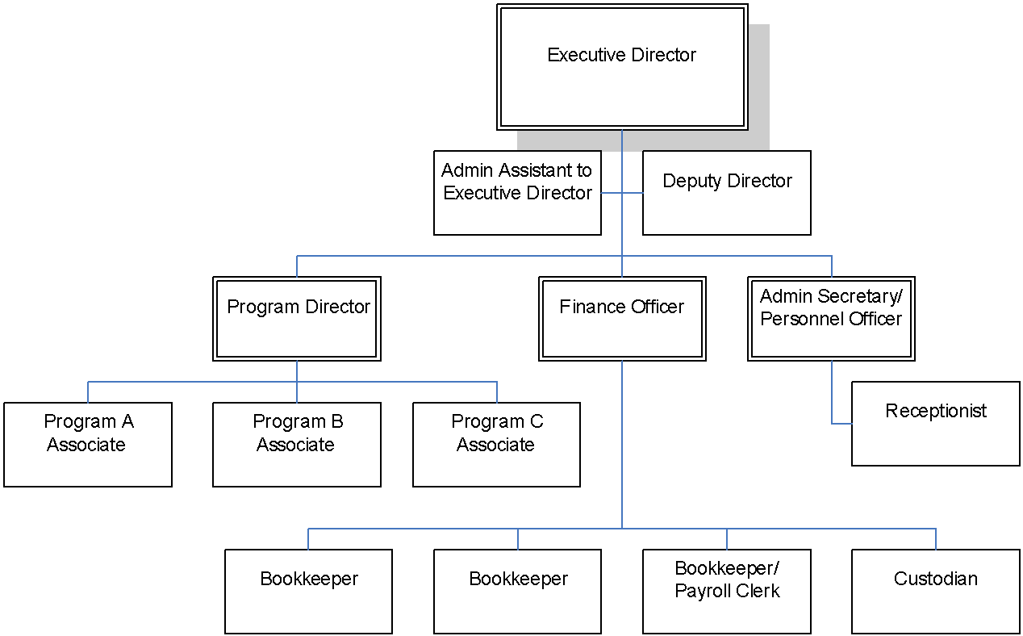
Cost Allocation Plan Certification

This is to certify that I have reviewed the cost allocation plan submitted herewith and to the best of my knowledge and belief:

- All costs included in this proposal [identify date] to establish cost allocations or billings for [identify period(s) covered by plan] are allowable in accordance with the requirements of the 2 CFR Part 200 Subpart E-Cost Principles and the Federal award(s) to which they apply. Unallowable costs have been adjusted for in allocating costs as indicated in the cost allocation plan.

- All costs included in this proposal are properly allocable to Federal awards on the basis of a beneficial or causal relationship between the expenses incurred and the Federal awards to which they are allocated in accordance with applicable requirements. Further, the same costs that have been treated as indirect costs have not been claimed as direct costs. Similar types of costs have been accounted for consistently.

I declare that the foregoing is true and correct.

Governmental Unit:
Signature:
Name of Official (printed):
Title:
Email:
Date of Execution:

This certification:
- Is a requirement per 2 CFR Part 200 Subpart E §200.415 and Appendix V Section E.4.;
- Must be submitted as part of the submission of the central service cost allocation plan; and
- Must be signed on behalf of the non-Federal entity by an individual at a level no lower than vice president or chief financial officer of the organization with authority to negotiate cost allocation plans for the organization.

