Certificate of Indirect Costs

For State & Local Governments and Indian Tribes

This is to certify that I have reviewed the indirect cost rate proposal submitted herewith and to the best of my knowledge and belief:

- All costs included in this proposal [identify date] to establish billing or final indirect cost rates for [identify period(s) covered by the rate(s)] are allowable in accordance with the requirements of the Federal award(s) to which they apply and the provisions of 2 CFR Part 200 Subpart E-Cost Principles. Unallowable costs have been adjusted for in allocating costs as indicated in the indirect cost proposal.

- All costs included in this proposal are properly allocable to Federal awards on the basis of a beneficial or causal relationship between the expenses incurred and the agreements to which they are allocated in accordance with applicable requirements. Further, the same costs that have been treated as indirect costs have not been claimed as direct costs. Similar types of costs have been accounted for consistently and the Federal government will be notified of any accounting changes that would affect the predetermined rate.

I declare that the foregoing is true and correct.

Governmental Unit:
Signature:
Name of Official (printed):
Title:
Email:
Date of Execution:

This certification:
- Is a requirement per 2 CFR Part 200 Subpart E §200.415 and Appendix VII Section D.3.;
- Must be submitted as part of the annual indirect cost rate proposal; and
- Must be signed on behalf of the non-Federal entity by an individual at a level no lower than vice president or chief financial officer of the organization.

SAMPLE PROPOSAL
Information and examples used in this proposal are fictitious and represent no particular Indian Tribal Government.

Part 1

Indian Tribal Government
123 Upper Street
Middletown, WA 97865

Mailing Address:

U.S. Department of the Interior
Office of the Secretary
Indirect Cost Services
Financial Management Directorate
Interior Business Center

650 Capitol Mall, Suite 4-300
Sacramento, California 95814-4745
Telephone # (916) 930-3803
Fax # (916) 930-3804

E-mail Address: ICS@IBC.DOI.GOV
Website: https://ibc.doi.gov/ICS/icrna

Filing instructions: Proposals and audited financial statements are recommended to be submitted electronically to ICS@IBC.DOI.GOV as attachments preferably in 3 files: 1) Part 1 Sample Proposal, 2) Part 2 Exhibits (in Excel format, and 3) Audited Financial Statements.

Do NOT mail hard copy if submitting electronically; doing so will delay the processing of your proposal.

The point(s) of contact listed in the proposal will receive an email from our office within five business days confirming the receipt of the proposal package. Please follow up to ensure that we have successfully received the package if you do not have receipt confirmation within five days.
TABLE OF CONTENTS

PART 1
CERTIFICATE OF INDIRECT COSTS 1
CHECKLIST 4
INTRODUCTION 6
POLICY STATEMENT ON DIRECT VERSUS INDIRECT COSTS 7
TREATMENT OF SPECIFIC COSTS 8
ORGANIZATION CHART 9
INDIRECT COST PERSONNEL JUSTIFICATIONS 10
TYPE OF RATE AND FISCAL PERIOD(S) WITH DESCRIPTION OF BASE 12
TIME ALLOCATION SYSTEM/METHODOLOGY DESCRIPTION & SAMPLE PAR 13

PART 2
EXHIBIT A: RATE COMPUTATION
EXHIBIT B: CARRYFORWARD COMPUTATION
DIRECT COSTS: EXHIBIT C: ACTUAL DIRECT COST BASE
EXHIBIT C-1: INDIRECT COST COLLECTIONS
EXHIBIT D: PROPOSED DIRECT COST BASE
INDIRECT COSTS:
EXHIBIT E-1: ACTUAL INDIRECT COST POOL
EXHIBIT E-2: PROPOSED INDIRECT COST POOL
EXHIBIT F: RECONCILIATION OF AUDITED FINANCIAL STATEMENT COSTS TO INDIRECT COST PROPOSAL
EXHIBIT G: DEPRECIATION SCHEDULE
EXHIBIT H: PROFESSIONAL SERVICES
EXHIBIT I: INDIRECT COST POOL SUPPORT (GL)
EXHIBIT J: INDIRECT COST COLLECTIONS SUPPORT (GL)

PART 3
AUDITED FINANCIAL STATEMENTS

Indirect Cost Proposal (ICP) Checklist (Indian Tribal Governments)
Please explain any box not checked on a separate page

Part 1

 | 1. Contact person information (preferably the person who prepared the proposal): | Page #_____
 | Entity Name and mailing address
 | Employer Identification Number (EIN)
 | Point-of-Contact Name and position title
 | Email address (very important)
 | Phone & fax numbers
 | 2. Signed Certificate of Indirect Costs indicating the period covered by the proposed rate. | Page #_____
 | 3. Entity’s written policy for allocating and identifying direct and indirect costs, i.e. Policy | Page #_____
 | Statement on Direct versus Indirect Costs.
 | 4. Treatment of Special Costs. | Page #_____
 | 5. Organization Chart. | Page #_____
 | 6. Indirect Cost Personnel Justifications for ALL positions listed in the pool. | Page #_____
 | 7. Timekeeping Narrative/current completed and signed time sheet. | Page #_____
 | 8. Type of Rate and Fiscal Period(s) covered by the proposal and description of the base. | Page #_____

Part 2

 | 9. Rate Computation, use the Exhibit most applicable to the type of rate requested. | Page #_____
 | (Exhibits A-1, A-2, or A-3)
 | 10. Carryforward Computation (required for 3rd year or later, Exhibit B). | Page #_____
 | 11. Direct Cost Base (Exhibits C and D) detailed to include all activities that benefit from the | Page #_____
 | indirect cost pool. Must include the following:
 | a. Total expenditures (reconcilable to the audit if using actual numbers);
 | b. Support for total Salaries and Wages (SW) if base is SW, or Salaries, Wages and Fringe Benefits (SWF);
 | c. All exclusions; including all indirect cost collections;
 | d. List all programs (grouped by funding agency) with Federal programs listed on top;
 | e. The amount of federal program expenditures identified must reconcile with the amount of federal expenditures identified on the Schedule of Expenditures of Federal Awards (SEFA) included in the audited financial statements.
 | 12. Indirect Cost Collections(Revenue Received) (Exhibit J) must be reconcilable to the financial | Page #_____
 | statements. If Indirect Cost Collections cannot be traced to the financial statements, the Entity must provide one of the following to support these numbers: (1) a copy of the audited general ledger showing the grand total for the indirect cost collections, (2) documents from the funding agency, or (3) a letter from the CPA who performed the audit. Same request for indirect expenditures.
 | 13. Indirect Cost Pool (Exhibits E-1 & E-2) detailed to include a breakdown of (1) indirect | Page #_____
 | salaries by position title, amount, and indirect percentage, and (2) all other indirect costs by line item. If actual indirect costs cannot be traced to the financial statements, the entity must provide one of the following to support these numbers: (1) a copy of the audited general ledger showing the grand total for the indirect cost pool or (2) a letter from the CPA who performed the audit.
 | 14. Reconciliation of Total Expenditures per Audited Financial Statements to Indirect Cost | Page #_____
 | Proposal (Exhibit F) when audited costs are used.
 | 15. Depreciation schedule (Exhibit G) if depreciation is included as indirect costs. | Page #_____
 | 16. Professional Services schedule (Exhibit H) | Page #_____

Part 3

 | 17. Applicable audited financial statements that meet the requirements of the Single Audit Act | Page #_____
 | of 1984, Public Law 98-502, as amended. If Entity is under the A-133 threshold ($750,000) and does not have an audit, then a copy of the Profit and Loss Statement or general ledger is required.

INTRODUCTION

This proposal is based on budget estimates for all programs to be administered by the [Indian Tribal Government] during the period October 1, 201X through September 30, 201X. All Federal, State, and Native American programs have been included in the proposal. We have also included audited financial statements for all programs and the indirect cost pool for FY 201X.
The individuals to contact in regard to this proposal are:

Mr. Bill Tall, Finance Manager
[Indian Tribal Government]
Tel. (888) 555-1234, x123
Fax (888) 555-1240
Email: btall@xxx.com

Ms. Jane Doe
XYZ Certified Public Accountants
678 Corner Road
Westernville, Washington 97643
Tel. (888) 668-3456
Fax (888) 668-3450
Email: jdown@xxx.com

POLICY STATEMENT ON DIRECT VERSUS INDIRECT COSTS

Direct costs consist of those costs that can be readily identified as a direct contract, grant, or program cost and addressed as benefiting a particular cost objective.

The following indirect costs incurred for the operation of the administration of the [Indian Tribal Government] have been classified as indirect costs in accordance with the standards for indirect costs as described in 2 CFR Part 200 issued by the Office of Management and Budget. For reasons itemized below, these costs have been determined to comply with the above stated criteria and are therefore to be consistently charged as indirect costs within the funding formulas determined by the cognizant agencies. All items listed below have been determined to benefit more than one cost objective and are not readily allocable to benefiting contracts, grants, and programs.

1. Salaries paid to the administrative staff of the [Indian Tribal Government].

2. Fringe benefits, including payroll taxes and medical insurance for the administrative staff.

3. Travel, including meals, lodging, and transportation costs for indirect personnel conducting Tribal business that is of an indirect nature (i.e., the benefit is not directly related to one program, but instead benefits many programs). Per diem follows the guidelines established for the Federal Government by the General Services Administration.

4. Insurance costs for the general umbrella policy and the fidelity bond of the Organization.

5. Office supplies, including office supplies used that cannot be specifically identified with a particular contract, grant, or program.

6. Telephone and utilities.

7. Consultants, audit fees, and preparation of the indirect cost proposal.

8. Legal fees paid to attorneys for legal information and representation related to allowable indirect activities (such as areas of accounting, personnel, and HR) are included in the indirect cost pool. Legal fees related to a direct cost activity or function is direct charged to that applicable activity or function. Legal fees related to general government activities (such as water rights and election issues) are direct charged to the applicable functions included in the direct cost base.

9. Repairs and maintenance of the Organization facilities that are utilized by contracts, grants, and programs.

Other indirect costs may be included in the administration of the indirect cost pool. Costs included in the indirect cost pool may not be limited to the above list; however, they are the only such costs foreseen at this time. Each cost is examined for compliance with prescribed criteria before being classified as an indirect cost.
TREATMENT OF SPECIFIC COSTS

Check the appropriate box that best describes how the following costs are treated:

1. Does the Tribe have a BIA program called “Aid to Tribal Government”?

(a) YES
(b) NO

2. Please describe how tribal membership enrollment and election costs are treated.

(a) We do not incur these costs
(b) As direct costs and included in the direct base.
(c) As indirect costs and included in the pool.
(d) As an exclusion (not included in the base or pool).
(e) None of the above. (please specify treatment)

[INDIAN TRIBAL GOVERNMENT]
ORGANIZATION CHART

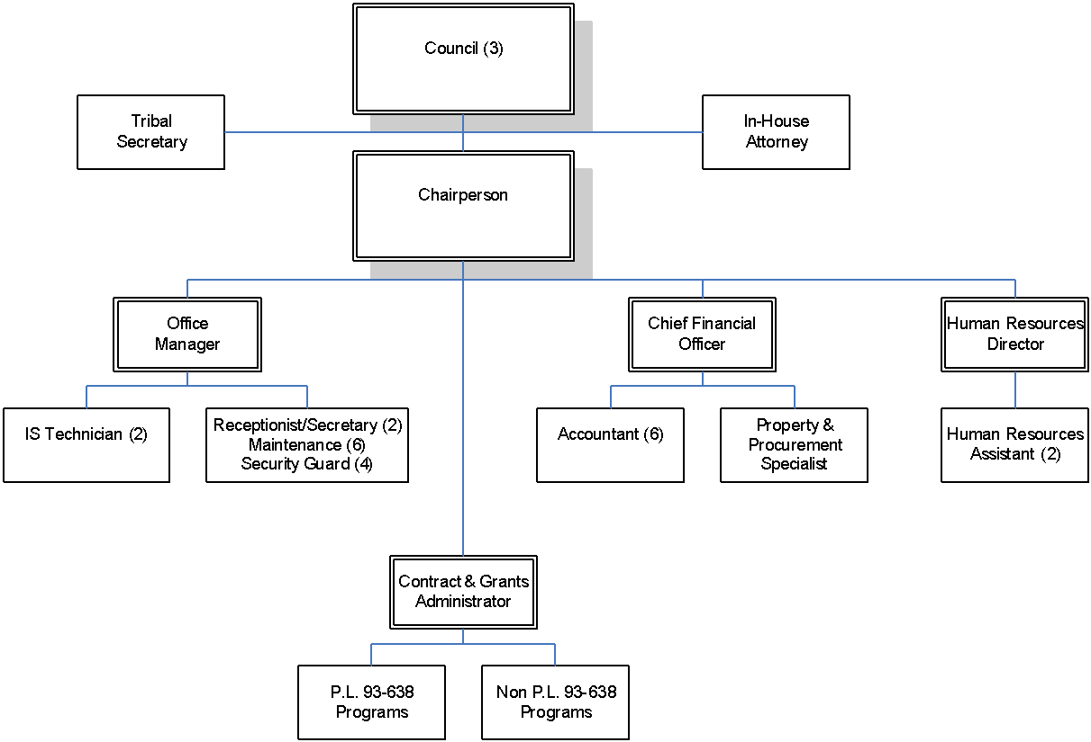

INDIRECT COST PERSONNEL JUSTIFICATIONS

In determining the allowable share of the [Indian Tribal Government]’s costs identified with administering programs, the Chief Financial Officer reviewed time and attendance records. Support of salaries and wages for personnel services of employees working on multiple activities or cost objectives is in accordance with 2 CFR Part 200 §200.430(i) and is part of the annual single audit review process. If substitute systems are used, they have been approved by the cognizant Federal agency prior to use.

The following account of each position should provide the necessary justification to fund administrative costs through the indirect cost pool.

CHIEF FINANCIAL OFFICER: This position is responsible for all accounting and financial activities of the [Indian Tribal Government], including investing of idle funds, preparing financial reports, and supervising general ledger maintenance, payroll, and grant/contract accounting. Since the Chief Financial Officer is responsible for the accounting and finance department and involved in program business activities, this position’s time is chargeable to indirect costs.

ACCOUNTANTS (6): Two accountants and four accounting clerks maintain the general ledger, including accounts receivable, accounts payable, payroll, and ensure compliance with the federal and tribal regulations. All of these positions are chargeable to indirect costs.

OFFICE MANAGER: This position is responsible for the overall coordination and management of the administrative services to the grants and contract programs as well as the smooth running of the various business departments. Program and department directors report to this position. The position is chargeable to indirect costs.

INFORMATION SYSTEMS TECHNICIANS (2): These technicians coordinate and maintain all personal computer and networking systems, purchase and install software, replace IT equipment and in general keep the network fully functioning. The time for these positions is chargeable to the administrative function (indirect costs).

PROPERTY & PROCUREMENT SPECIALIST: This position is part of the business department and provides purchasing control and support to the grants and programs. This position also keeps inventory of tribal assets and performs periodic inventories. All of the Specialist’s time is applicable and chargeable to indirect costs.

CONTRACT & GRANTS ADMINISTRATOR: This position provides support to the program directors in the area of grants and contracts administration. This position also provides assistance in the areas of long range planning, grant and contract development, budgeting, community planning processes, and policies and procedures development. The time for this position is chargeable to indirect costs.

HUMAN RESOURCE DEPARTMENT (3): The HR Department consists of a director and two assistants. Together, they are responsible for developing and maintaining personnel systems and policies which are utilized by grant and program personnel. These systems and policies may include the maintenance of files, keeping records, hiring and firing of personnel, and providing for promotions and pay increases. These positions are all chargeable to indirect costs.

RECEPTIONIST/SECRETARY (2): These positions are part of the administrative department and provide secretarial services, maintain contact with all levels of management, and establish cooperative working relationships. These positions involve high-volume contact with all program staff and governmental agencies, including tribal, federal, state, and local entities. All of the receptionist/secretary’s time is applicable and chargeable to indirect costs.

MAINTENANCE DEPARTMENT (6): A maintenance staff of six is employed for most preventive maintenance work, coordination, quality control, emergencies and to perform many work tasks that are not feasible to contract out. Three of the staff members work exclusively at the Tribe’s enterprise. The remaining staff is chargeable to indirect costs.

SECURITY GUARDS (4): These positions are responsible for the overall security of the tribal complex housing program and administration personnel. The guards are responsible for keeping order, reporting disturbances to the proper authority, keeping people and property safe and in an orderly condition. The portion of their time attributed to the security of the Tribal administration building is chargeable to indirect costs.

Type of Rate and Fiscal Period(s)
We are requesting to negotiate the following indirect cost rate(s) (check applicable box and provide the fiscal period). Include applicable Exhibit for type of rate selected.

Type of Rate & Fiscal Period
 |  |  | Use Exhibit *
(a) Fixed Carryforward Rate for FY ending: |  |  | A-1
(b) Provisional/Final Rates for FYs ending: |  |  | A-2
(c) Predetermined Rate for FY ending: |  |  | A-2

* All Exhibits are located in Part 2 of the Proposal

Description of the Base used in the Rate Computation (Check applicable box):

 |  | WITH REGARD TO ALL OPTIONS PLEASE NOTE:
 | Base (Direct Salaries and Wages, excluding | These are typical examples of the distribution
 | Fringe Benefits) | bases used to calculate Indirect Cost Rates.
 | Base (Direct Salaries and Wages, including | Please select the one that provides the most
 | Fringe Benefits) | equitable distribution.
 | Base (Total Direct Costs, less capital | Only select the method used by your organization.
 | expenditures and passthrough funds)
 |  | Do not change the distribution base without prior
 | Base (Other – Please describe) | approval from the cognizant Federal agency.

TIMEKEEPING NARRATIVE

If the indirect percentage for non-council staff employee(s) shown on Exhibits E-1 & E-2 is less than 100%, please include a description of the tribal entity’s timekeeping system or methodology to support compliance with the standards of 2 CFR Part 200, Subpart E, §200.430(i).

Description of timekeeping system or methodology: The allocation of time shown on the time sheet is based on _____________________(fill in the blank).

SAMPLE TIMESHEET OR PERSONNEL ACTIVITY REPORT (PAR)

(Attach a recent completed and signed timesheet or PAR that best illustrates the allocation of time spent on various direct and indirect functions.)

