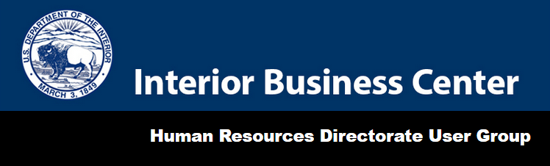

Memorandum

DATE: Friday, October 2, 2020
TO: Human Resources Directorate User Group Representatives
FROM: Julie Bednar, Associate Director, Human Resources Directorate, IBC
SUBJECT: Payroll Tax Deferral Update regarding Separating Employees

This memorandum provides IBC’s customer agencies with additional information on the Payroll Tax Deferral per the Presidential Memorandum signed on August 8, 2020. On September 29, 2020, the IBC received written guidance from the Office of Management and Budget (OMB) and the Office of Personnel Management (OPM) regarding separating employees.
The following criteria apply to employees who separate from an agency before the end of the last pay period in the tax deferral period, Pay Period (PP) 26 of 2020, for IBC’s payroll processing schedule. The employees share of the Old Age, Survivors, and Disability Insurance (OASDI) tax withholding, also known as Social Security, to withhold from an employee’s last paycheck:

- If an employee is transferring from one Federal agency to another without a break in service, the employee should repay the deferred taxes during the established payback period (January through April 2021).

- If an employee is separating from an agency including resignation, retirement, and other forms of separation or termination (but not transferring to another agency without a break in service), the following applies:

  - For employees paid bi-weekly: The payroll provider should withhold the employee’s share of OASDI for the final pay period, plus the amount of payroll taxes deferred over the prior two pay periods.
  - For employees paid monthly: The payroll provider should withhold the employee’s share of OASDI for the final pay period, plus the amount of payroll taxes deferred in the prior pay period.

The IBC is working diligently toward implementing the withholding process to comply with OMB and OPM’s direction. We have many outstanding debt and tax questions related to the withholding of the deferred OASDI tax. Once IBC receives official guidance to ensure we have all requirements related to debt and tax reporting, we will provide another update. IBC is committed to our clients and will continue to pursue the information to properly update our systems to support our customers and their employees.

User Group Representatives are encouraged to share this information with employees in your agencies.
As a reminder, all media communications on the Payroll Tax Deferral must be vetted through OMB. If an agency receives a media request, please refer those requests to Rachel Semmel at rachel.k.semmel@omb.eop.gov for a response.
The Internal Revenue Service guidance can be found here:
https://www.irs.gov/pub/irs-drop/n-20-65.pdf.
The IBC will continue to work with the OMB to finalize the requirements for questions pending resolution.
If you have any questions, please utilize the following points of contact:
Thomas Larson, Chief
Personnel and Payroll Systems Division
303-969-7703
Thomas_D_Larson@ibc.doi.gov

Christine Zertuche-Rocha, Chief
Payroll Operations Division
303-969-6616
Christine_L_Zertuche@ibc.doi.gov

Doug Pokorney, Deputy Associate Director
Human Resources Directorate
303-969-7200
Douglas_B_Pokorney@ibc.doi.gov

Julie Bednar, Associate Director
Human Resources Directorate
303-969-7200
Julie_P_Bednar@ibc.doi.gov

