A reorganization for [insert organization name] has been proposed for [insert effective date]. A thorough review of the proposed changes will be completed by the servicing HR Specialist and the HR FPPS Security Point of Contact (SPOC) and any concerns or issues will be discussed with you before proceeding with the processing of the reorganization.
In order to ensure that the organizational changes are accurate, timely and within legal compliance, we are providing this packet of information as well as the required forms needed in order to process this request. Organizational changes impact HR across all branches, therefore close coordination is required.
Please identify a Point of Contact (POC) who will work closely with the HR FPPS SPOC and HR Servicing Team throughout the process and ensure that the required documents are received by the due date(s) identified.
Upon receipt of all required documents, the HR FPPS SPOC will proceed with the organizational changes and the HR Servicing Team will keep the POC updated throughout the process. The Human Resource Operations Division (HROD) requests that all reorg documents are completed and turned in to HR at least 6 weeks prior to the effective date.
Required Reorg Documents Include:
- Reorganization Crosswalk: This document will identify affected employee’s current organizational information and the new organizational information. This document should indicate all employees and contractors for the organization
- IBC HR Systems Access Form: This form is used for new users that are requesting access to HR systems or users that need access terminated
- Current and Proposed Organizational Chart(s): This document should display the structure or relationship of hierarchy all within one page for current org structure and one page for proposed org structure
- Approved and Signed Reorganization Documentation: This document should contain reasoning for and the description of proposed changes to the organization. In addition, the org/agency will need to provide our office (and the union, if applicable) with the final documentation indicating higher level approval of the reorganization with signature

Additional reorg information contained in this reorg packet includes:
- Sample Reorganization Memorandum (Page 8): This sample document can be used to create a reorg memorandum. A reorg memorandum is not required but can be an option for documenting the approved and signed reorganization.
- Organizational Entity Definitions (Page 9): Review this document closely to assign the proper naming convention for each organizational code
- Org Code Numbering Scheme (Page 12): Utilize this document to identify the appropriate way to develop the new organizational code(s)

If there are any questions, do not hesitate to contact your servicing HR Specialist.

Reorganization Crosswalk
Below is a sample of the Reorg Crosswalk spreadsheet that must be completed for the reorg package to be complete.
- Blue columns are to be completed by the org/agency
- Green columns are to be completed by the HR Servicing Team
- Orange columns are to be completed by the HR FPPS SPOC
Org Code Info Tab
List all org codes, both current and future, within the entire org/agency being affected by the reorganization.
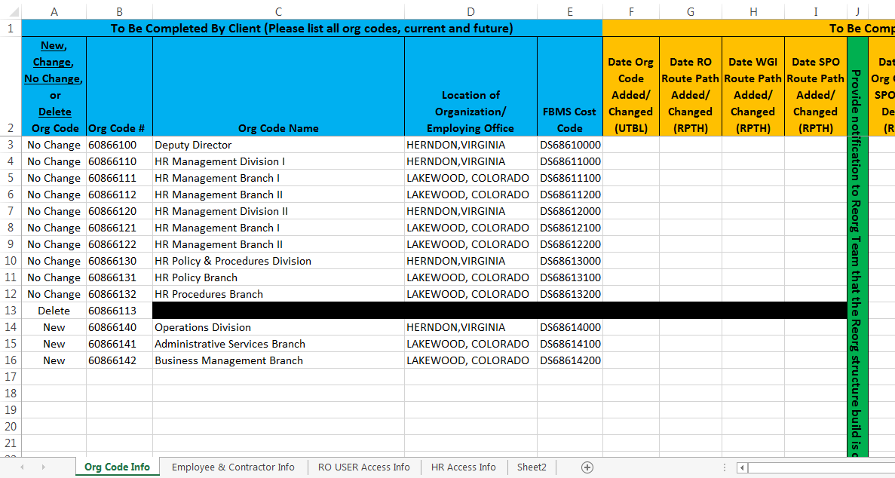
- Column A: Indicate whether the org code information (columns B-E) is new, will change, will not change, or will be deleted
- Column B: List all current org codes in the organization and any new org codes being created by the reorganization
- Column C: List the exact Org Code Name that will be printed on the SF-50
- Column D: List the Official Office Location that will be printed on the SF-50
- Column E: List the FBMS Cost Code that will be tied to the org code
Employee & Contractor Info Tab
List all Employees and Contractors that will be impacted by the reorganization.
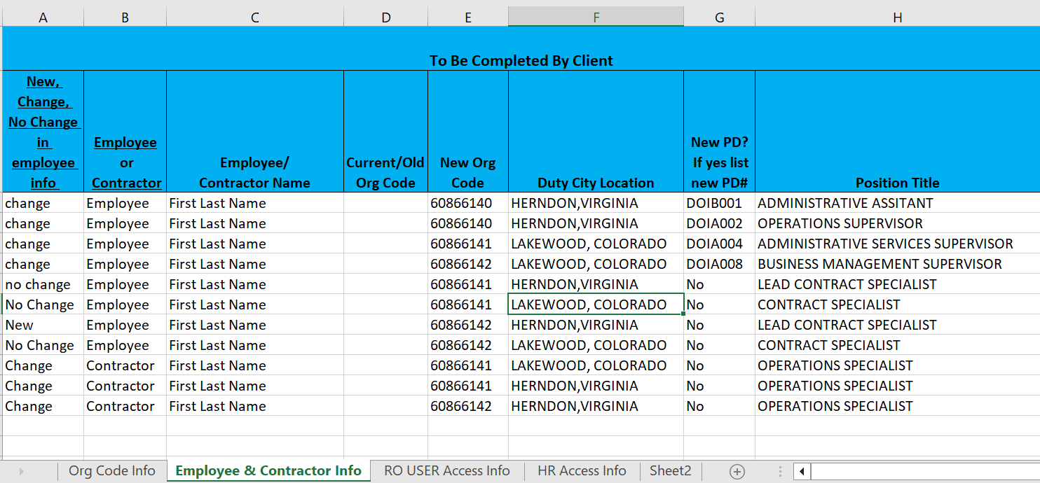
- Column A: Identify the appropriate type of action for the employee (i.e. – change, no change, new)
- Column B: Identify if the employee listed in column B is a Federal Employee or Contractor
- Column C: List the Employee/Contractor name
- Column D: List the current (or what will become the old) org code that the Employee/Contractor will be moving from
- Column E: List the org code that the Employee/Contractor will be moving to
- Column F: List the new duty city location for the Employee/Contractor
- Column G: If a new Position Description (PD) is being assigned to the Employee, list the new PD number. If there is no change in PD number type “No”
- Column H: List the Employee’s new position title

RO USER Access Info Tab

The HR FPPS SPOC will provide the agency with a list of users that currently have access to the FPPS System. Please complete all other columns in blue and Access Request Forms (if needed).
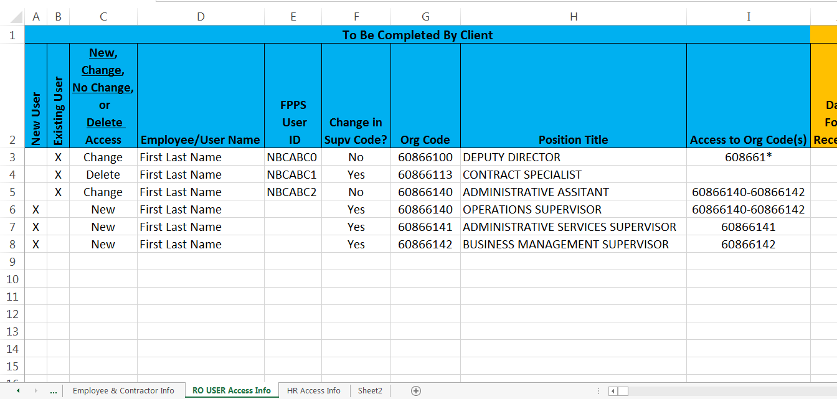
- Column A: Place an ‘X’ for any employees that are requesting system access for the first time
- Column B: Place an ‘X’ for users that already have access to HR systems
- Column C: Identify if the user’s access is new, will change, will not change or will be deleted
NOTE: If a user is indicated as “New” or “Delete” in column C complete the IBC HR Systems Access Request Form and submit it to the HR FPPS SPOC for processing
- Column D: List the employee’s name. For current users this will be completed by the HR FPPS SPOC
- Column E: This column will be complete by the HR FPPS SPOC for current users. For new users leave this column blank
- Column F: Identify if there is a change in supervisor code for the employee
- Column G: Identify the users new org code
- Column H: Identify the users new position title
- Column I: Identify the users new access range being requested

Current and Proposed Organizational Charts
Below is a sample of the Proposed Organizational Charts that must be completed for the reorg package to be complete. Follow the process below to complete all required information for the current and proposed organizational chart(s).
The current and proposed org charts must include:
- Current org chart fit on one page
- Proposed org chart fit on one page
- Supervisor name
- Org code name (same name indicated on the Reorg Crosswalk sheet)
- Org code number (same as indicated on the Reorg Crosswalk sheet)
- FBMS cost center code (same as indicated on the Reorg Crosswalk sheet)

Current Org Structure

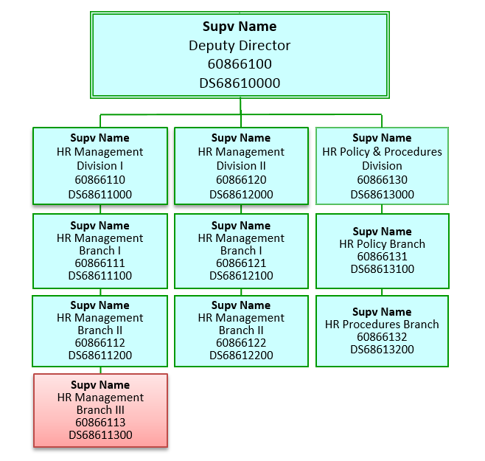

Proposed Org Structure

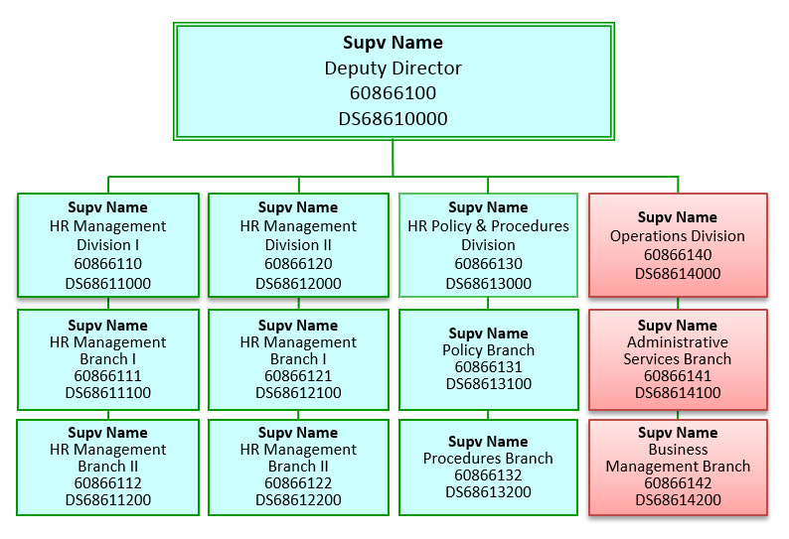
Sample Reorganization Memorandum
Below is a sample of a Reorganization Memorandum that may be used as part of the “Approved and Signed Reorg Documentation” for the reorg package but is not required.
(date)

MEMORANDUM

To: name
Chief, Human Resources Office

From: name
Chief, (organization)

Subject: Reorganization of the _____________ Division/Branch/Office

Effective (date), the attached reorganization for the ______________ Division, _____________ Branch will be effected. The reorganization will result in the addition of one section to the Branch. The new section will be titled “___________ Section”. All current GS-(series) technician employees will be realigned to the new section. All current GS-(series) specialist employees will remain assigned to the Branch level. No changes in position descriptions will result from this reorganization.

The reason for the addition of the new section is (explain what work processes, e-payroll, etc. necessitated the change)

The following attachments are provided to further describe the reorganization:

- Overview of organization chart
- Listing of all Branch employees

If you have any questions regarding this reorganization, contact (Supervisor’s name and title) at 303-969-xxxx.

Cc: AFGE Local 1114 (if applicable)

Attachments

Organizational Entity Definitions

This document provides definitions to use in determining what names to give the organizational entity boxes shown on an official IBC org chart; the organizational position titles to give to the Incumbent of the highest-level supervisory position in each of those organizational entities, and how the placement of the boxes on the chart should relate to each other. See Page 12 referencing organizational code numbering scheme to match organizational definitions.

BRANCH: An organizational entity with responsibility for performing work in direct support of, and reporting to, a Division. The Branch Chief would have full supervisory authority over the Chiefs of any subordinate Sections; however, a Branch does not have to have subordinate Sections. The org chart nomenclature for this organizational entity is “_______ Branch”. The organizational position title for an Incumbent of the highest supervisory level position in a Branch is “Chief, ________ Branch.” On an org chart, a “Branch” is shown as a line organization under the “Division” to which it directly reports.

CENTER: An organizational entity, normally equivalent to a Branch that has responsibility for performing work in direct support of, and reporting to, a Division or its equivalent. A “Center” would seldom have under it any subordinate organizations. The term “Center” is used in keeping with historical or contemporary nomenclature within an occupational field. The org chart nomenclature for this organizational entity is “______________ Center”. The organizational position title for an Incumbent of the supervisory position in a “Center” is “Chief, ___________ Center”. On an org chart, a “Center” is shown as a line organization below a Division or equivalent level.

DIRECTORATE: The first major organizational entity below the IBC Director level that reports directly to the IBC Director; has senior management level responsibility over one or more major product line(s) or program area(s); and under which there are 2 or more Divisions, each containing subordinate Branches. The org chart nomenclature for this organizational entity is “Directorate, ______________”. The organizational position title for an Incumbent of a Directorate position is, “Associate, Director, ________”. In addition, the organizational position title could include a supplemental title mandated by law or Executive Order, e.g., CIO, CFO, Bureau Procurement Executive. On an org chart, a Directorate is shown as a line organization below the IBC Director level.

DIVISION: A major organizational unit under which there are 2 or more Branches, with responsibility for performing work in direct support of, and reporting to, a Directorate. The Division Chief would have full supervisory authority over the Chiefs of any subordinate Branches. The org chart nomenclature for this organizational entity is “_______ Division”. The organizational position title for an Incumbent of the highest supervisory level position in a Division is “Chief, ________ Division.” On an org chart, a “Division” is shown as a line organization under the “Directorate” to which it directly reports.

GROUP: An organizational entity with responsibility for performing work in direct support of, and reporting to, an “Office”. The staff in a “Group” would normally include an individual with full supervisory authority over employees in the “Group”. The org chart nomenclature for this organizational entity is “_______ Group”. The organizational position title for an Incumbent of the supervisory position within a “Group” is “Chief, ________ Group.” On an org chart, a “Group” is shown as a line organization under the “Office” to which it directly reports.

OFFICE: An organizational entity at a Branch or higher level that has responsibility for performing and/or coordinating work having a direct effect on all subordinate organizational entities in its direct subordinate chain of command. An “Office” would seldom exist below the Branch level. An “Office” would include an individual with full supervisory authority over other employees assigned to the “Office” and over the supervisors in any “Groups” reporting to the “Office”.

At the Director’s level, an “Office” performs and/or coordinates work that has a direct affect IBC-wide, or performs, in a geographic field office separate from the Director, work in support of the Director.

At the Directorate level, an “Office” performs and/or coordinates Directorate level work that has a direct affect on all subordinate organizations in the Directorate; OR performs, in a geographic field office separate from the Directorate, work in support of the Directorate.

At the Division level, an “Office” performs and/or coordinates Division work that has a direct affect on all subordinate organizations in the Division; OR performs, in a geographic field office separate from the Division, work in support of the Division.

At the Branch level; an “Office” performs and/or coordinates Branch work that has a direct affect on all subordinate organizations in the Branch; OR performs Branch work in a geographic field office separate from the Branch, work in support of the Branch.

The org chart nomenclature for this organizational entity is “_______ Office”, which may include a descriptor such as “Area” or “Regional”. The organizational position title for an Incumbent of the supervisory position within an “Office” is “Chief, ________ Office.” On an org chart, an “Office” is shown as a staff organization off to side of the Director, Directorate, Division or Branch to which it directly reports.

SECTION: An organizational entity with responsibility for performing work in direct support of, and reporting to, a Branch. The Section Chief would have full supervisory authority over the Supervisors in subordinate Unit or Group; however, a Section does not have to have subordinate Units. The org chart nomenclature for this organizational entity is “_______ Section”. The organizational position title for the Incumbent of the supervisory position in a Section is “Chief, ________ Section.” On an org chart, a “Section” is shown as a line organization under the “Branch” to which it directly reports.

TEAM: An organizational entity with ongoing responsibility for performing work in direct support of, and reporting to, a “Group”. The staff in a “Team” would normally include an individual with full supervisory authority over employees on the “Team”. The org chart nomenclature for this organizational entity is “_______ Team”. The organizational position title for an Incumbent of the supervisory position within a “Team” is “Chief, ________ Team.” On an org chart, a “Team” is shown as a line organization under the “Team” to which it directly reports. (This type of team that is formally identified on an official organizational chart is not meant to be confused with an ad hoc team convened to work on a temporary project. For this latter type of team that is not formally identified on an official organization chart, team members usually continue performing their regular duties in addition to the teamwork, or are assigned to work on the team for a temporary period of time; once the team project is completed, the team members would return to their position of record.)

UNIT: An organizational entity with responsibility for performing work in direct support of, and reporting to, a Section. The staff in a “Unit” would normally include an individual with full supervisory authority over the employees in the “Unit”. A “Unit” is usually the lowest organizational level in a Division. The org chart nomenclature for this organizational entity is “_______ Unit”. The organizational position title for Incumbent of the supervisory position in a Unit is “Chief, ________ Unit.” On an org chart, a “Unit” is shown as a line organization under the “Section” to which it directly reports.

Organizational Code Numbering Scheme
Please utilize this document to identify the appropriate way to develop the new organizational code(s)
