Employee Express (EEX) Login Procedures Update

Employee Express accounts are currently only available using PIV cards

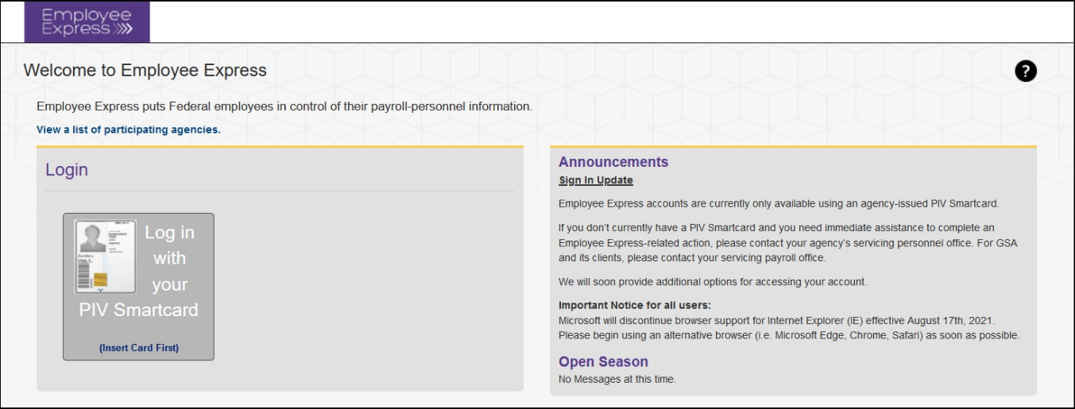
The Login ID/Password feature on Employee Express has been temporarily removed while the system is being updated to implement multi-factor authentication. The new Employee Express login procedure should be available within approximately three weeks.

EEX Login Tips
PIV card is not working? Use the Forgot Password link to establish a new Password, to be used in conjunction with reestablishing PIV card access.
Need to register a PIV Smartcard? Go through the same process above using the Forgot Password link.
If you don’t currently have a PIV card and you need immediate assistance to complete an Employee Express-related action (e.g., address changes, tax changes, allotment changes, etc.), please contact your servicing HR Specialist.
_______________________________________________________________________________________________

Resources
Employee Express
Employee Express Resource Page on IBC Customer Central

Questions?
If you have any questions, please contact your servicing HR Specialist.

