eOPF Browser Update
Effective August 17, 2021, Microsoft is discontinuing support of Internet Explorer. To avoid interruption of service when accessing eOPF, please discontinue the use of the Internet Explorer browser and begin using one of the following eOPF supported browsers:
- Microsoft Edge (preferred)
- Google Chrome
- Firefox

NOTE on Certificates:
When selecting certificates to log into eOPF using your PIV card, please be sure to select the certificate with the PIV card icon.
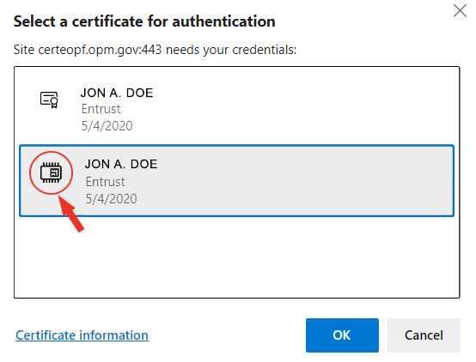
_______________________________________________________________________________________________

Questions?
If you experience any issues or have any questions accessing your eOPF, please contact OPM for user ID, password, or technical issues:
- eopfhelpdesk@opm.gov
- 1-866-275-8518
For all other eOPF assistance including documents in your file, please contact your servicing HR Specialist.

Resources
- eOPF Employee Quick Reference Guide
- OPM eOPF Employee User Guide

