Review your Home Address for Accuracy

Does IBC have your current address on file?
Your Home Address is normally your official mailing address of record for HR and payroll purposes. IBC uses this address for mailing items to you such as the Form W-2, Employee Benefit Statements, Thrift Savings Plan Statements, and Leave and Earnings Statements.
To review your Home Address for accuracy, log in to Employee Express and select “Home Address” on the left-side Personnel/Payroll menu.
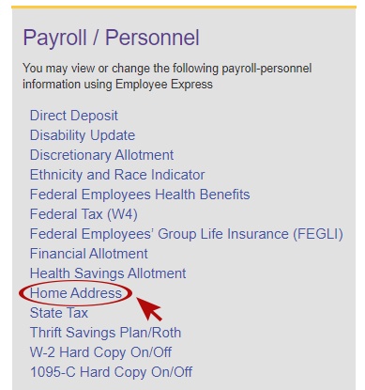

How to Update your Home Address
If you need to update your Home Address, follow these steps:
- Enter the changes to your Home Address and press the “Save” button.
- The confirmation page will appear. Your action is not complete until you accept the change on the confirmation page.
- To complete the action, click “Confirm” to update your Home Address.
Once you have confirmed the change, the system will provide you the date in which the change will be effective. The Home Address change is transmitted to IBC the next business morning for processing. Your action is placed in a pending status until the pay period effective date.

IMPORTANT
A change to your Home Address will not change your State Tax. Please see your Servicing Personnel Office to change your State for tax purposes.
Notification of Home Address changes are NOT sent to the Federal Employees Health Benefit (FEHB) providers. If you are currently enrolled in FEHB, please contact your FEHB provider directly with your Home Address change.
_______________________________________________________________________________________________

Questions?
For assistance with Employee Express user IDs and passwords, please submit a help desk request by clicking on the help icon, question mark, located in the top right hand corner of the Login page on the Employee Express website.
For all pay and leave related questions, please contact the Customer Support Center.

